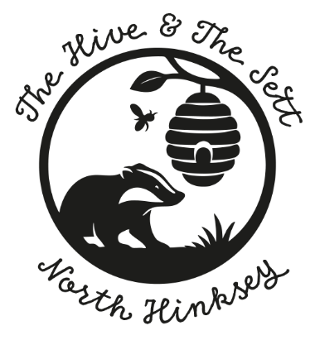

Ethos, Curriculum and Pedagogy

A Parent’s Guide

From 1 September, North Hinksey Nursery will follow the Early Years Foundation Stage (EYFS) statutory framework, DfE September 2026, which sets the standards for learning and care for children from Birth to five. https://assets.publishing.service.gov.uk/media/6a5f8e4fb00f3323bf1a23a1/EYFS_group_and_school_based_from_September_2026.pdf

EYFS 2026 prescribes “All children deserve the care and support they need to have the best start in life. Children learn and develop at a faster rate from birth to five years old than at any other time in their lives, so their experiences in early years have a major impact on their future life chances. A secure, safe, and happy childhood is important in its own right. Good parenting and high-quality early learning provide the foundation children need to fulfil their potential.
“The EYFS sets the standards that all early years providers must meet to ensure that children learn and develop well and are kept healthy and safe. It promotes teaching and learning to ensure children’s ‘school readiness’ and gives children the right foundation for good future progress through school and life.”
“The EYFS is about what children learn, as well as how they learn. Effective practice is a mix of different approaches. Children learn through play, by adults modelling, by observing each other and through adult-guided learning.”
The EYFS seeks to provide:
• Quality and consistency in all early years settings, so that every child makes good progress, and no child gets left behind.
• A secure foundation through planning for the learning and development of each individual child and assessing and reviewing what they have learned regularly.
• Partnership working between practitioners and with parents and/or carers.
• Equality of opportunity and anti-discriminatory practice, ensuring that every child is included and supported.
DfE 2026

EYFS specifies requirements for learning and development and for safeguarding children and promoting their welfare.
The learning and development requirements cover:

- the areas of learning and development which must shape activities and experiences.
(educational programmes) for children in all early years’ settings

- the early learning goals that providers must help children work towards (the knowledge, skills and understanding children should have at the end of the academic year in which they turn five)
- assessment arrangements for measuring progress (and requirements for reporting to parents
and/or carers)

And lastly outlines the safeguarding and welfare requirements, covering the steps that providers must take to keep children safe and promote their welfare.

Principles of EYFS
All children develop at a different pace, and they do not necessarily do things in the same order as each other. It is paramount that children’s life experiences are considered and getting to know them through building relationships with the Key person as well as listening to Parents/ carers. The enabling environment is not just the physical space and resources, inside and outside, it is the emotional environment created by enthusiastic, motivated, and well-trained practitioners, who can use their professional judgement and knowledge to support children’s learning and development.
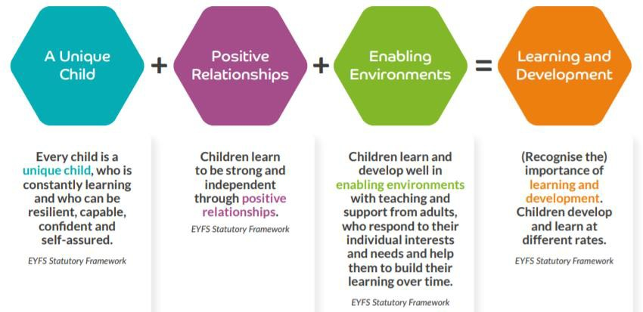

Our Ethos
“We believe children learn when they are feeling safe, secure and nurtured. Children learn through all their experiences. Through these experiences we look to create provocations and opportunities for Child-led learning and the development of skills.
Children’s well-being is paramount to us. We support them, whilst they learn to self-regulate, share, and express themselves, whilst investigating their own interests, guiding them through various opportunities, whether its cooking or Forest school, playing a game with others, or sharing a book with an adult. We engage their curiosity through play and interactions, extending their knowledge sensitively.”

Child Centered Approach
The child is at the Centre of all that we do. We value their input, through observations and talking to them, we can support their holistic development, in a timely and appropriate way for them as individuals. We aim to encourage them to develop skills that they may need in their lives, through education and beyond. We recognise that without them feeling comfortable and confident in themselves, the learning process is less effective, so by getting to know them and their families, experienced and well-trained practitioners teach them through modelling; scaffolding; supporting.

Teaching
EYFS 2021 stated that a “Teacher should be understood to refer to any practitioner working with the child”. We are advocates for Ofsted’s definition of Teaching: -
“Teaching should not be taken to imply a ‘top down’ or formal way of working. It is a broad term which covers the many different ways in which adults help young children learn. It includes their interactions with children during planned and child-initiated play and activities:
  - Communication and modelling language,
  - Showing,
  - Explaining,
  - Demonstrating,
  - Exploring ideas,
  - Encouraging,
  - Questioning,
  - Recalling,
  - Providing a narrative for what they are doing,
  - Facilitating.
It takes account of:
  - The equipment adults provide,
  - The physical environment,
  - The structure and routines that establish expectations.

Integral to teaching is how practitioners:
  - Assess what children know, understand, and can do,
  - Take account of their interests and dispositions to learn (characteristics of effective learning),
  - Use this information to plan children’s next steps learning,
  - Monitor their progress.
Ofsted 2019

Play

Children have a right to play; this is recognised as vital to their wellbeing and development as outlined in the United Nations Convention on the Rights of a Child (1989). We support children’s play not just for fun but because it provides so many opportunities for children to engage, in different activities and practice their skills; immerse themselves in things that interest them, whilst finding out about themselves, others and the world around them. We provide lots of opportunities for open-ended play, which is flexible, and children can explore, take risks, and challenge themselves to their own limits, helping them to develop their self-confidence.
Through play, children can build on existing knowledge and with the addition of positive interactions, with peers and adults, can make new connections and develop understanding.
Our environments inside and outside facilitate play. They are safe, spacious and exciting. Resources are introduced to enhance and encourage play, based on children's interests.

We all know how children need opportunity to play with other children, and we aim to facilitate this
essential life skill, which promotes language development, self-esteem and self-confidence and gives children a keen sense of wellbeing.
Our Early Years Practitioners have a deep understanding of how different types of play support learning and development. Children may be pursuing different purposes through exploratory play using objects; sensory; schematic play; pretend play (alone or in groups with small world or real-life objects). They may be engrossed in superhero or fantasy play; co-operative play, with others, physical play; rough and tumble or risky play. Practitioners will observe play and consider how best they can support it, if needed, to either extend it or just learn something about the child’s current interests and understanding.

Care
At North Hinksey Nursery we feel Children need care and love. We chose our team members for their nurturing qualities—they are attentive, dependable, protective, and compassionate. They treat children with affection and have regards to their rights and consider what is best for the individual child. We feel the care of children is intertwined with play and learning. If a child feels cared for, well supported and happy (a good sense of wellbeing), they will thrive physically, emotionally, and have capacity to learn new skills, or practice ones they are developing.
Effective practice considers and plans for the care of young children such as washing, toileting, getting changed, eating drinking and napping, and these aspects are embedded in daily routines to allow time, to complete these tasks, in a group provision, in a kind and respectful way. Practitioners also see these times as opportunity to have positive, respectful 1:1 interaction with children, and to build trusting relationships. The Key person approach also further supports this, with consistent staffing within groups of children.

Inclusion
We aim to identify, understand, and break down any barriers to participation and belonging. We listen to individual children, through their voice but also through observations. Children have a right to be heard, as established via Article 12 on United Nations Conventions of the Rights of the Child (UNCRC 1989) and is embedded through the Special Educational Needs and Disability Code of Practice 0-25 years (DfE/ DoH 2015). Through this we would seek familial views, as well as the child’s, in making plans on how best to support them. As a setting we would also seek help and support from outside agencies, such as Speech and Language, or the Early Years Special Educational Needs Inclusion Teams (EYSENIT).
Curriculum Summary
Our curriculum is our plan for children’s holistic development and learning experiences, which we aim to provide children with, offering a broad range of experiences within the context of a group setting. This diagram demonstrates how Key skills and characteristics of effective teaching and learning overlap the seven areas of learning prescribed by EYFS 2026.
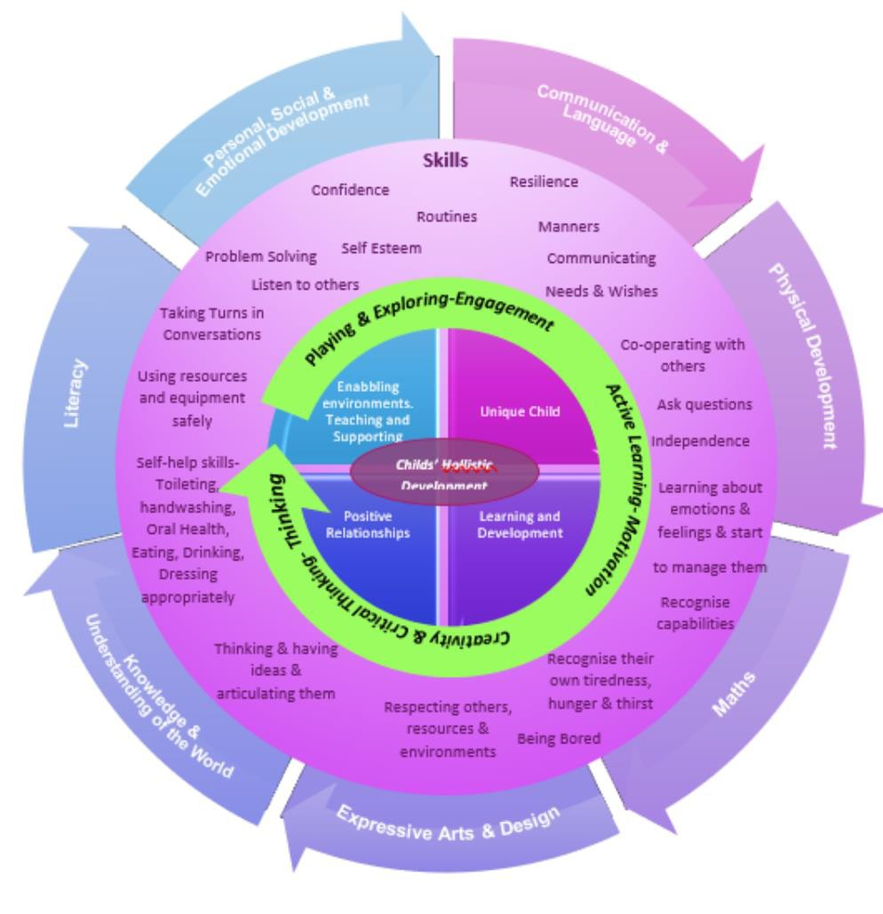

As we care for children from the age of two until they start in reception, there is a strong emphasis on the three Prime areas: - Personal, Social and Emotional Development; Communication and language; Physical development.

We really want to support children in embedding these aspects of their development, give them lots of time to practice and master these skills as well as use the specific areas to introduce new concepts and support children’s acquisition of knowledge and understanding, alongside giving further opportunity to develop the prime areas further.

Characteristics and effective teaching and learning.
To support Children in an ever-changing world we need to support their development of positive dispositions, provide experiences to enable them to make decisions and choices; to innovate; experience challenge and take responsibility; thinking flexibly, and critically, helping them learn “how to learn”, enabling them to respond to things effectively, that they may come across in their lifetimes. This is a statutory element of EYFS 2026 and is a central responsibility of our early years provision. There are three aspects: -

Playing and Exploring

 | At Nursery children will be learning to: |  |  |  | Examples of how we would support this:
 | Realise that their actions influence the world, so they want to keep repeating them. |  |  |  | Encourage exploration of the world around them. Talk to them about their lives, things they have done, seen. Provide resources for them to re-play real life experiences.
 | Make choices and explore different resources and materials. |  |  |  | Introduce interesting things, such as real-life objects. Provide loose parts, open-ended resources for children to play freely with, outdoors and inside.
 | Plan and think ahead about how they will explore or play with objects. |  |  |  | Provide different pebbles, shells, and other natural materials for children to explore and arrange freely.
 | Guide their own thinking and actions by talking to themselves while playing. For example, a child doing a jigsaw might whisper under their breath: “Where does that one go? – I need to find the big horse next.” |  |  |  | Help children to develop more control over their actions by giving them many opportunities to play freely and find their own ways of solving problems. When appropriate, sensitively provide a helpful commentary. We might suggest: “Why don’t you look for the biggest pieces first?” but  would not find it for them.
 |  | Make independent choices.  Do things independently that they have been previously taught |  |  | We provide a well-organised environment so that children know where materials and tools are and can access them easily. We provide enough materials and arrange spaces so that children can collaborate and learn alongside peers. Once children know how to use scissors, they can use this skill to achieve what they want to do.
 |  | Bring their own interests and fascinations into early years settings. This helps them to develop their learning. |  |  | We extend children’s interests by providing stimulating resources for them to play with, on their own and with peers, in response to their fascinations. We join in with children’s play and investigations, without taking over. We talk with them about what they are doing and what they are noticing. Provide appropriate non-fiction books and links to information online to help them follow their interests
 |  | Responding to new experiences that you bring to their attention |  |  | We regularly provide new materials and interesting things for children to explore and investigate. We introduce children to different styles of music and art and give them the opportunity to observe changes in living things in the setting, and around the local environment.

Active Learning

 | At Nursery children will be learning to: |  |  | Examples of how we would support this:
 | Use a range of strategies to reach a goal they have set themselves. |  |  | We provide plenty of high-quality, open-ended resources for children to play with freely, inside, and outdoors. We suggest children can use wooden blocks to make lots of different structures.
 | Begin to correct their mistakes themselves. For example, instead of using increasing force to push a puzzle piece into the slot, they try another piece to see if it will fit. |  | We help young children to develop by accepting the pace of their learning. Give them plenty of time to make connections and repeat activities.
 | Keep on trying when things are difficult. |  |  | We help children to think about what will support them most, taking care not to offer help too soon. Some children learn by repeating something hard on their own. They learn through trial and error. Others learn by asking a friend or an adult for help. Others learn by modelling. They watch what you do or what other children do.

Thinking Creatively and Critically
At Nursery children will be learning to: | Examples of how we would support this:
Take part in simple pretend play. For example, they might use an object like a brush to pretend to brush their hair, or ‘drink’ from a pretend cup. Sort materials. For example, at tidy-up time, children know how to put different construction materials in separate baskets | We help children to find their own ideas by providing open-ended resources that can be used in many ways. We encourage and enjoy children’s creative thinking as they find new ways to do things. We recognise children need consistent routines and plenty of time so that play is not constantly interrupted. We are reflective and flexible.
Review their progress as they try to achieve a goal. Check how well they are doing. Solve real problems: for example, to share nine strawberries between three friends, they might put one in front of each, then a second, and finally a third. Finally, they might check at the end that everyone has the same number of strawberries. | We help children to reflect on and talk about their learning through using photographs and memory books. We share in children’s pride about their achievements and their enjoyment of special memories. We prompt conversation with questions like: “Do you remember when…?,” “How would you do that now?” or “I wonder what you were thinking then?”
Use pretend play to think beyond the ‘here and now’ and to understand another perspective. For example, a child role-playing the “Billy goats gruff” story might suggest that “Maybe the  troll is lonely and hungry? That’s why he is fierce.” | We help children to extend their ideas through sustained discussion that goes beyond what they, and you, have noticed. We encourage them to consider ‘how’ and ‘why’ things happen.
Know more, so feel confident about coming up with their own ideas. Make more links between those ideas. | We help children to come up with their own ideas and explanations. If we saw a woodlouse we could ask: “What’s similar about woodlice and other insects?” We could use and explain terms like ‘antennae’ and ‘thorax.’ We could look at books or digital resources to discover more.
Concentrate on achieving something that’s important to them. They are increasingly able to control their attention and ignore distractions. | We offer children many different experiences and opportunities to play freely and to explore and investigate. We make time and space for children to become deeply involved in imaginative play, indoors and outside.

Self-regulation and executive function
Language development is central to self-regulation. It is important to remember a child needs to develop lots of aspects such as interactions; listening and attention; play; understanding, before they can express themselves, and lastly before they master speech sounds, which is often the thing parents notice that may not be quite right. At North Hinksey Nursery we recognise this progression of skills and support children through them also helping them learn to recognise how they may be feeling, through positive and sensitive interactions.
Self-regulation encompasses impulse control; behavioural control; emotional competence; self-direction and executive function. Considering these through interlinked aspects of emotions and understanding we aim to support children, in managing their thoughts, feelings and behaviour. We do this through three basic strategies for co-regulation.

- Positive Relationships- Adults provide warm and responsive relationships with the
children making them feel comforted, cared for, respected and supported during times when they are feeling upset, and /or stressed. We share how things are going with parents so they can support their children at home in the same ways.

- Enabling Environments- Emotional and physical environments are created through
careful considerations, with good routines which enable children to be confident to try new things and take risks if they want, and practice strategies, repeatedly.

- Learning and Development- Self regulation skills are taught by suggesting strategies,
modelling, practicing, and scaffolding to enable children to practice their self-regulation skills.

Executive Function

For children this includes their ability to: -
- Focus and pay attention- Follow simple instructions, follow boundaries.
- Hold information in their minds- Store and retrieve information and use it again for a purpose
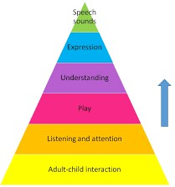
- Regulate their behaviour- Think before acting and keep feelings in check.
  - plan flexibly-Be able to adapt to changing situations and start to consider the different points of views of others.
As children learn to self-regulate, they have more capacity to develop their executive functions.
If you want to find out more about how we may support children’s learning and development of executive, function this article explains things further.

Pedagogy
It is widely recognised that Early Years Development sets the foundations for lifelong learning, behaviour, and health. Children are powerful learners, and all children can make progress with the right help and support. At North Hinksey Nursery we use a mix of approaches in the way we instruct children. We like to provide lots of opportunities and experiences to challenge children and broaden their skills, and we do this through modelling; scaffolding and demonstrating. We observe children’s abilities, talk to them and their parents, and consider how to enhance their knowledge and skills. We allow children to have a go and support them if it looks like they want help, of they directly ask for help. We also encourage peer-to-peer support, to enable them to see there is value in collaborating with other children, as well as seeking help from adults. Our resources are accessible, and we encourage children to make their own decisions. We also encourage creativity, demonstrating ideas but allow children to direct their projects in a direction they want to make. We do not want to stifle creativity by prescribing a way of doing things so you will receive some interesting creations of the children’s own directive!
Seven areas of learning
Children’s learning is not compartmentalised and there is a great deal of overlap of learning taking place all the time. This is holistic development. All the areas of learning affect each other, though the three prime areas are the foundations of all learning.
Prime areas: - Personal, Social and Emotional; Communication and Language; Physical
development. They are of equal importance and are core aspects of child development. The development is time-sensitive because of developmental factors, with rapid brain connections made particularly in the first 3 years of life.

Communication and Language
Listening, attention and understanding- underpinning language, Speaking- verbal interactions, sharing ideas and thoughts, expressing oneself.
This underpins all areas of learning. We have meaningful and real conversations with children, extending their thoughts and knowledge through open ended conversations. We model, scaffold and recast early language and work more intensively along speech therapists if we feel the child needs further support. Through storytelling, reading books, singing and discussions we strive to broaden children’s vocabulary with a good understanding of ideas and concepts and the meaning of words.




Personal, Social and Emotional Development-
Sense of self-Who we are, making relationships-who we relate to and get along with others, and Understanding emotions- how we feel.
To enable children to flourish and have a strong sense of wellbeing ready for learning we pay attention to their emotionall rneeds, identify how they feel about them-selves and others. We create an environment to create trusting relationships, so children can learn to become independent and secure in themselves and develop friendships with others.
Physical Development-
Gross Motor-whole body physicality, Fine Motor-control and precision in hand-eye co-ordination. Both aspects are intrinsically linked and develop side by side. Balance, co-ordination, proprioception (the body’s ability to understand its own position in a space), Physical strength, reflexes and reactions, and Bi-lateral movements such as holding paper with one hand, whilst drawing with the other, all need developing. Then the fine motor skills, involving fingers, hands and wrists, supporting hand and eye co- ordination, object manipulation, finger isolation, hand strength, clenching, pinching etc. all required for self-care as well as writing and other life skills!

Specific Areas

Literacy
Comprehension- Understanding what words mean, Word reading- for pre- schoolers’ this is an understanding that written words carry meaning Writing- children will start to understand the uses of writing, develop mark making and maybe start to write some recognisable letters, but there are lots of other factors involved before children write, not just the physical development but also the understanding of what to write, ability to articulate ideas and the structure of sentences through learning to speak.
We aim to in-still a life-long love of reading by sharing books, fiction, non-fiction and demonstrate how literacy can be used to support learning across all areas. We talk around the books and ask open ended questions and get children to actively participate in books. We also develop their own story telling skills, scribing for them, and encouraging their own writing skills. We also extend vocabulary through conversations, recasting of words, and explaining their meani ng in an age-appropriate way.



Math’s-
Number- learn to count and understand what a number is, and what it represents, 1-10, start to recognise number of objects without counting, Numerical patterns- children naturally look for patterns in things and problem solve.
We support children using math throughout everything we do, whether it’s counting how many children there are for lunch, how many chairs are needed or measuring things in a cooking activity or making playdough. We aim to encourage children to explore mathematical concepts such as, bigger/ smaller, puzzles and shapes. We learn to count through stories, singing, playing and then if children are managing the concepts will go deeper with them exploring things such as the way numbers can be composed and simple sums, e.g., if I have one and you have one, we have two. We want to develop children’s self-esteem and enthusiasm for all things mathematical, in a playful way, encouraging their growing confidence in this area.

Understanding the World
Past and present- History, People culture, and communities- Geography Natural world- Science.


For Nursery this means we guide children to make sense of the world around them, in our community. We consider and talk to the children about their personal experiences, past and present, and share knowledge and vocabulary, to extend their learning and understanding of social, cultural and technological and ecological factors in our world, in an age-appropriate way, as families would at home, through discussion, books, songs, rhymes, cooking and craft activities. We look for opportunities to broaden experiences such as local visits to shops, libraries, parks etc. and invite visitors to share their experiences with the children such as the health visitor and local fire brigade, (outside of Covid19). We observe and learn about nature in our environment at pNurserybut also through local walks and Forest school too.

Expressive Arts and Design
Creating and Materials- engaging with and using a wide range of creative activities, different media and materials, Being Imaginative and Expressive- this is crucial to develop individual imagination and creativity for an ever-changing world.
We aim to provide a broad range of opportunities to express themselves through different genres of music, forms dance and music and movement as well as offer a variety of creative mediums, whilst extending vocabulary and techniques opening up a world of possibilities of children’s own creations. To embed ideas and techniques we repeat ideas and encourage participation. We also sing lots of rhymes and songs in groups and spontaneously if a subject links to something the children are exploring. We play with songs too and make up rhymes and songs to engage children and have fun!

Assessment
Assessment is important to enable parents/ carers and practitioners to recognise children’s progress, understand their needs and plan activities to support development. Our assessment is ongoing (formative). Practitioners observe and get to know children and ask parents to observe what they have noticed too. We share what we feel children’s interests and needs are and plan to extend through teaching and learning experiences, reflecting this knowledge of individual children.
There is a much greater emphasis through EYFS 2025 for Educators to spend less time on paperwork and collecting physical evidence and more time on positive interactions and activity with children. Practitioners use their professional Judgement to make a “best fit” of where a child is developing. If parents, carers, or educators have any concerns, discussions should be had, and further investigation may be undertaken into how best to support the child.
The only statutory written summary we would provide is the Two-Year Check which will be.
completed by Key Persons, outlining the child’s development, predominately in the Prime areas,
identifying strengths and if there are any areas of concern. If there are significant concerns or an identified SEND, we would develop a targeted plan and seek external support as appropriate.
We will share progress with parents verbally and through scrap books produced with the children, “Memory Books” as we aim to not prioritise the production of such documentation over quality time spent with the children.

English as an additional Language (EAL)

When assessing EAL children in communication and language and literacy skills, it will be in English. If the child is not at appoint whereby, they have a strong grasp of English Language, we will explore, with parents, what the child’s skills are in their home language and whether there is cause for concern around language delay.

